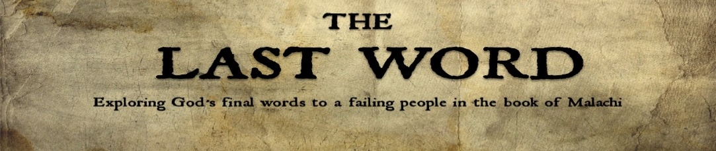
The Final Words of the Last Word
Malachi 4:1-6

Theme of Malachi – God’s call for His people to genuinely love,
fearfully worship and joyfully hope in His name.

YOU CAN BE _______ THE DAY OF JUDGMENT IS COMING

The Lord of Heaven’s Armies says, “The day of judgment is coming” - Malachi 4:1 (NLT)

1. The Day of Judgment Will Be _____ and __________
The Lord of Heaven’s Armies says, “The day of judgment is coming, burning like a furnace. On that day the arrogant and the wicked will be burned up like straw. They will be consumed—roots, branches, and all.” - Malachi 4:1

2. The Day of Judgment Will Be __________ and __________
“But for you who fear my name, the Sun of Righteousness will rise with healing in his [its] wings. And you will go free, leaping with joy like calves let out to pasture. 3 On the day when I act, you will tread upon the wicked as if they were dust under your feet,” says the Lord of Heaven’s Armies. - Malachi 4:2–3 (NLT)

YOU CAN ___________ FOR THE DAY OF JUDGMENT THAT IS COMING
1. Prepare for the Day of Judgment by Following God’s _______
“Remember to obey the Law of Moses, my servant—all the decrees and regulations that I gave him on Mount Sinai for all Israel.” - Malachi 4:4 (NLT)

2. Prepare for the Day of Judgment by Looking for God’s ________ _____

“Look, I am sending you the prophet Elijah before the great and dreadful day of the Lord arrives.” - Malachi 4:5 (NLT)

